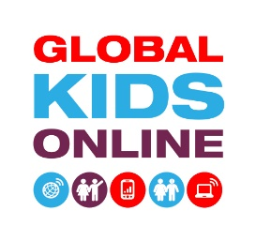
GLOBAL KIDS ONLINE STUDY
Invitation letter to schools: Global Kids Online project

Dear …

Global Kids Online is a UNICEF-funded cross-national project researching how children are using the internet around the world. Our aim is to learn from children’s experiences to help policy-makers, educators and governments make the internet better for children everywhere.

We intend to conduct school-based focus groups and individual interviews with children aged 9 to 17. We would like to ask the children about how they use the internet, and the sorts of things they have seen and done online, including things that they have liked and things that they have not liked or that have bothered them.
The interviews will take place between [insert dates]. The results will only be presented for the whole group of children, and no information identifying schools or individual children will be reported or published.
As the [country] partner, we at the [research centre] hereby request your support to enable us to interview about 12 children in your school: one group with four boys, one group with four girls, and two individual interviews with boys and two with girls.

We know that school timetables are very full, but this is important research and we hope you can help us. We can also show you our materials (interview guide, children’s consent form, information leaflet, etc.).

Add sentence about national/local process for research ethics approval.

We very much hope you can help us in our work, and we will be in touch by phone or email shortly.

Yours sincerely,

[Name of researcher]

[Research centre]

For any queries pertaining to the research, contact [name of researcher], [contact details – email, telephone].

