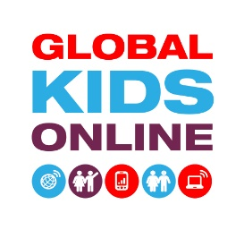
GLOBAL KIDS ONLINE STUDY
Information letter for parents

Invitation to take part in the Global Kids Online study

Global Kids Online is a UNICEF-funded cross-national project researching how children are using the internet around the world. Our aim is to learn from children’s experiences to help policy-makers, educators and governments make the internet better for children everywhere.

What will happen if you agree that your child can take part?
We intend to conduct home-based surveys with children aged 9 to 17 and one of their parents. We would like to ask the children about how they use the internet, and the sorts of things they have seen and done online, including things that they have liked and things that they have not liked or that have bothered them. We also would like to talk to parents about their own and their children’s internet use.
The survey interviews will take place between [insert dates] and will last about 45 minutes. The results will only be presented for the whole group of children, and no information identifying the household, individual children or their parent will be reported or published.
You and your child can withdraw from this study at any time, without giving a reason for withdrawing and without it affecting your future relationship with the research team.
Add sentence about national/local process for research ethics approval.

Returning the consent form
If you agree to both you and your child taking part in this study, please complete, sign and return the Consent form to the research team.

Getting in touch with research team members
If you have any questions about the project or the survey you can contact [name of researcher], [research centre]. Their contact details are: [telephone number] and [email].
For any additional information on the project, please consult the website at www.globalkidsonline.net
The project has been approved by the [add explanation about local/national research ethics approval].

Thank you for your valued time and participation!

