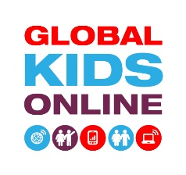

The research is about…
- We are studying how children are using the internet around the world.
- We want to find out how children get online and what kinds of things they do when they are online.
- We also want to understand what children like and don’t like about the internet.
Who are we?
- Global Kids Online is a network of researchers in many countries around the world.
- In your country the research is carried out by our team from [research centre]. The person responsible is [name of researcher].
Address
Address line 2
Phone number
Email address
www.globalkidsonline.net

How will we do the research?
By talking to children in groups or separately.

What will the focus group be like?
There will be around five children sitting around a table in a room in [location, e.g., your school] with [name of researcher]. We will ask you questions about the internet and how you use it. The discussion will last between 1 and 2 hours, with a short break in the middle. We will record the discussion.

What will the interview be like?
We will ask you questions about the internet and how you use it. It will be similar to the group discussion, but the interview will only be with you. We will record the interview.

Can I change my mind about taking part or answering?
Yes, of course. You can change your mind or leave the room anytime you want to. You can also skip any questions you don’t want to answer.

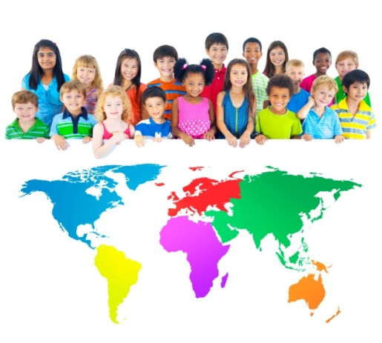

Will my name be used?
No, we’ll give you a different name and we’ll change the name of your school, so that no one reading about the project knows who you really are.

Is it confidential?
- Yes. We won’t tell anybody what you said.
- [If there is mandatory reporting of child abuse, add] However, if you tell me something about someone who is hurting you or putting you in danger I will have to report this to [insert...a social worker/the police/the government, etc.].

What will happen afterwards?
- We will listen to the recording from your discussions and those from other schools, and then we’ll write about the experiences of young people with the internet (e.g., in a book or a report).
- It takes a long time to write a report, but once it is ready, you will be able to find it here: www.globalkidsonline.net.
- The results of this project will be discussed with people who can make the internet more enjoyable and safer for children and young people. Your opinion will help them to do that.

Can I get more information?
Yes, of course. Contact [name of researcher] on number [phone number] or email: [email]. Or you can talk to any researcher who is in the school.

Yes, I want to take part.

Remember: There are no right or wrong answers. We are simply interested in hearing about your experiences.

Please fill out this form, sign it and give to the researcher(s).

I agree to take part in an interview for the research project Global Kids Online.

My name:

Today’s date:
Please sign here:

